Ideation Phase
Brainstorm & Idea Prioritization Template

Date | 06 April 2026
Team ID | 69bd2f9cc71a9ebd6a50e3b1
Project Name | Smart Library request workflow in Servicenow
Maximum Marks | 4 Marks

Brainstorm & Idea Prioritization Template:
- Brainstorming and idea prioritization is an important step in developing the Smart Library Request Workflow. It helps identify problems in the current library system and generate efficient digital solutions using ServiceNow.
- This phase ensures that the most impactful and feasible idea is selected for implementation.
Reference: https://www.mural.co/templates/brainstorm-and-idea-prioritization
Step-1: Team Gathering, Collaboration and Select the Problem Statement
The team collaborated to analyze existing issues in traditional library systems. Several challenges were identified:
- Manual book request process
- No real-time tracking of requests
- Delays in approval from librarians
- Lack of centralized system
- Poor communication between users and admin
Step-2: Brainstorm, Idea Listing and Grouping
During brainstorming, multiple ideas were generated to solve the identified problem:
- Online book request form
- Automated approval workflow
- Notification system (Email alerts)
- Book availability tracking
- User dashboard for request status
- Admin panel for managing requests
All ideas were collected without filtering to encourage creativity and innovation.
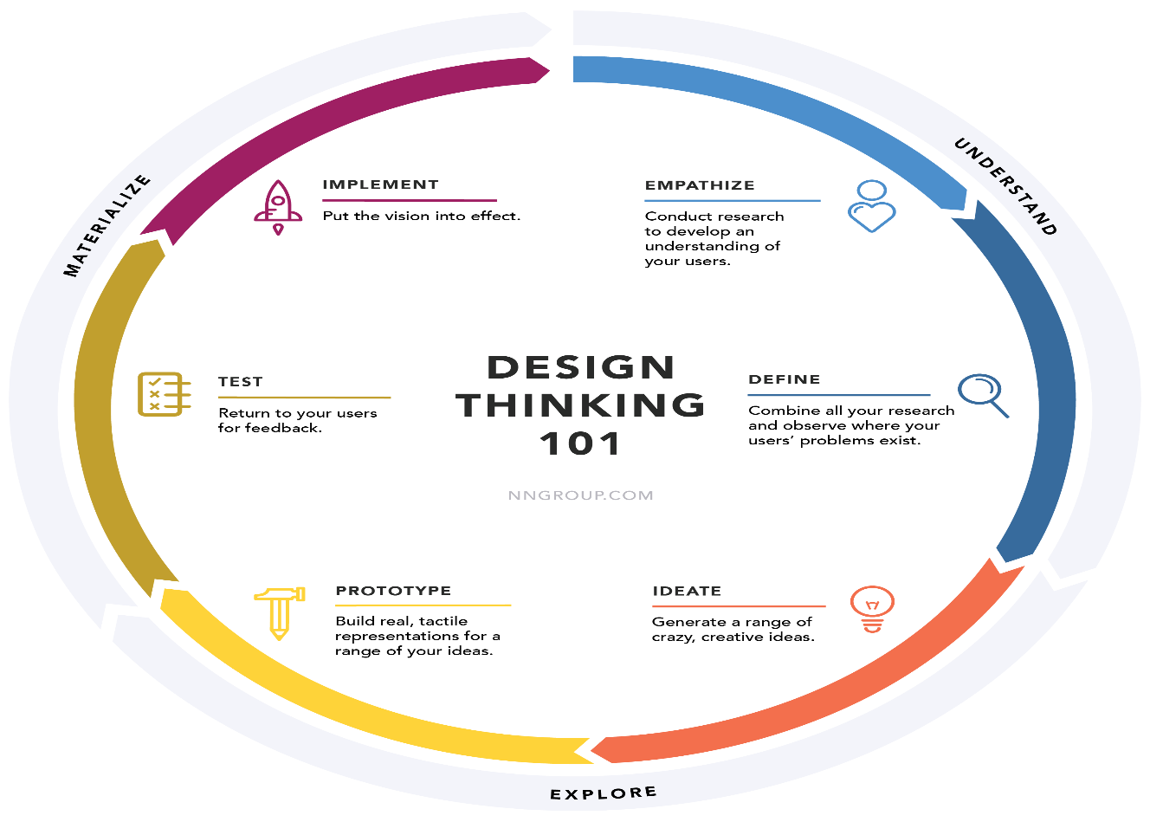

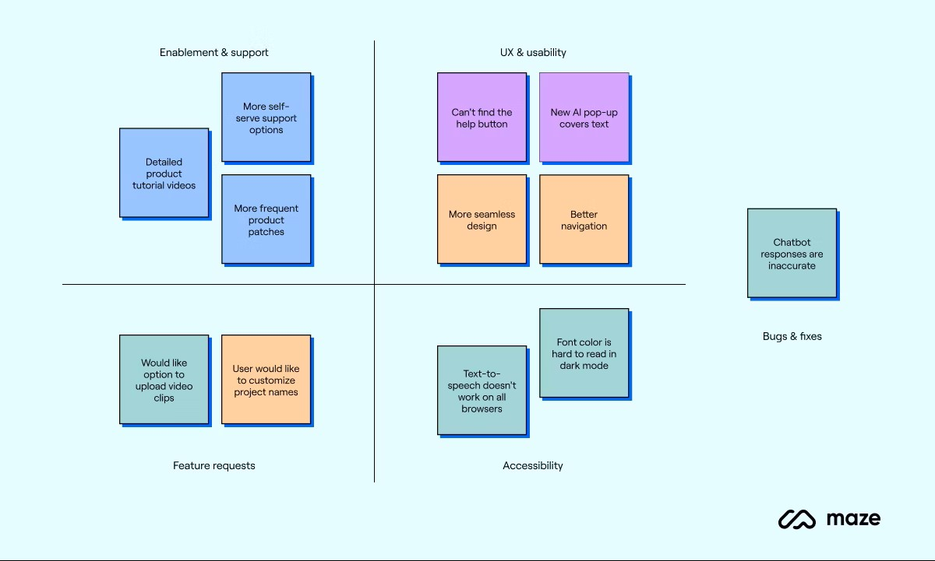
Step-3: Idea Grouping
The generated ideas were grouped into categories:
User Features
- Book request form
- Request tracking
Admin Features
- Approval/rejection system
- Request management
System Features
- Notifications
- Database storage
This grouping helped in organizing the ideas logically and understanding system requirements.

Step-4: Idea Prioritization
The ideas were evaluated based on:
- Feasibility
- Impact
- Implementation complexity
A prioritization matrix was used to select the most important features:
High Priority
- Book Request Form
- Approval Workflow
- Notifications
Medium Priority
- Request Tracking Dashboard
Low Priority
- Advanced analytics
